Pymp esel an teylu | 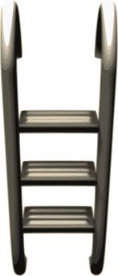  It’s raining | They don’t like beer
We like milk
Pymp liw yn Kernewek |  | 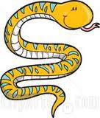
 | Py hanow osta? | It’s windy

 |  | Pleth osta trigys?
Py dydh yw dha bennbloedh? |  | Fatla genes?
They have a dog with them | I need a new coat | Mis-Genver bys dhe vis-Metheven
 |  | The sun is shining.
Pes bloedh osta? |  | Dydhyow an seythun

Yskynnewgh ha

 |  | Deg bys dhe ugens
I like drinking wine | We have a new car | She has four chairs
They don’t like beer
Write the letter now! |  | Mann bys dhe dheg

DiYskynnewgh

You must read that book |  | Mis-Metheven bys dhe vis-Kevardhu
 |  | Yn py stevell a wre’ta koska?
I read a book each week | That boy is lazy | Hwegh bro keltek
Tri lyver an Ordinali |  | Pymp eneval

